Linux Misc Terminal Commands
Dan Richter
11 Sep 2020

Alright, I know the last couple of articles contained a lot of information. This one will be a little lighter to read. We’re going to go over some terminal commands that are not used a lot, but you should know they are there for when you do need them.

man

We talked briefly about this one earlier, but ‘man’ will bring up the Manual for a specific program you need help with. This come in handy when you know the command you want to use, but can’t remember the switch you need to get the desired output.

In this example, let’s take a look at the man page for the ‘ls’ command. This gives you instant access to 245 lines of information about the ‘ls’ command, including switches, author, where to find further information, and even the authors and how to report bugs.

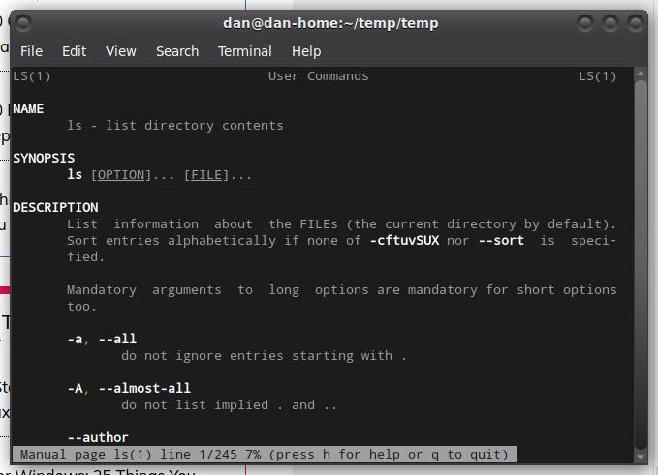
If you are every bored while at the terminal, take a look at some of the information contained in these ‘man’ pages. They can be very helpful in understanding everything you can do. And, before you ask, yes, you can run ‘man man’ to get 693 lines of information about the man program. :)

tar

If you are coming from a Windows background, you are probably familiar with a ‘.zip’ archive file. It is basically an archive file that will contain other files and/or directories. When you download programs off of the internet, they will usually be archived in some way. While zip is popular for Windows systems, and can be used in Linux as well, tar is very popular in the Linux world. I could write an entire article just on using tar, but instead I’ll go over a few basic command lines you can use.

Create a tar Archive File
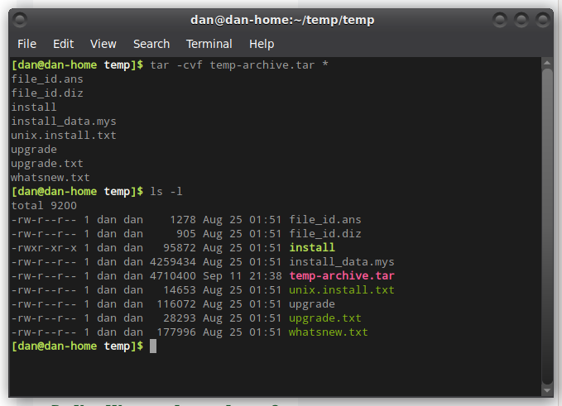
If you look at the command I typed in, you’ll noticed I used the program ‘tar’. The command line parameters are:
-c Creates a new .tar archive file
-v Verbosely show the .tar file progress
-f File name type of the archive file
temp-archive.tar is the name of the archive to create
* Tells it to archive everything contained inside this directory

Create a tar.gz Archive File

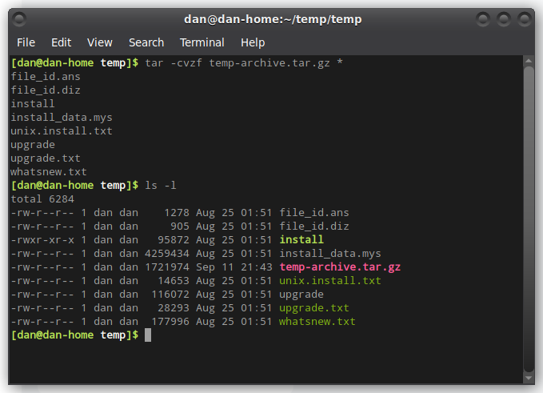
If you take a close look at the file size comparison between the archive in this screenshot and the previous, you will notice this one actually compressed the files, so they take up less space. A tar file will only archive them.

In this command line, we added the ‘z’, and also the ‘.gz’ to the end of the archive name. This told tar to compress all the files as they are added to the archive.

Create tar.bz2 Archive File

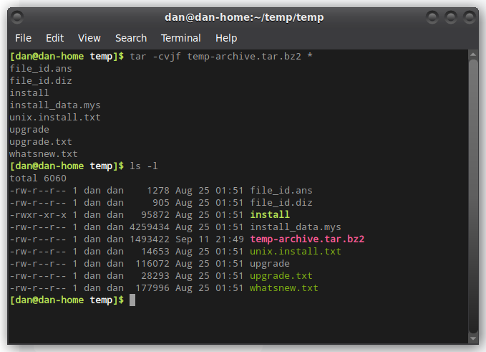
This time, we added a ‘j’ option to the command. Also take a look at the file size of this file, compared to the other two. It’s a fair amount smaller than the others. Using the bz2 compression takes a little bit longer to compress and decompress, but the results are better. This is incredibly useful when archive sizes are huge.

Untar a tar Archive File

Untar a tar Archive File
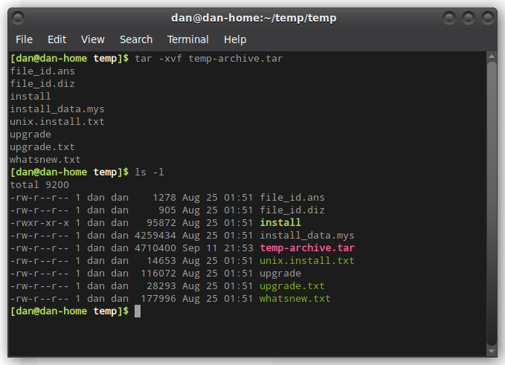
Notice the similarities in the command line? When extracting a .tar archive, just change the ‘c’ for create, to ‘x’ to extract.

Uncompress a tar.gz Archive File

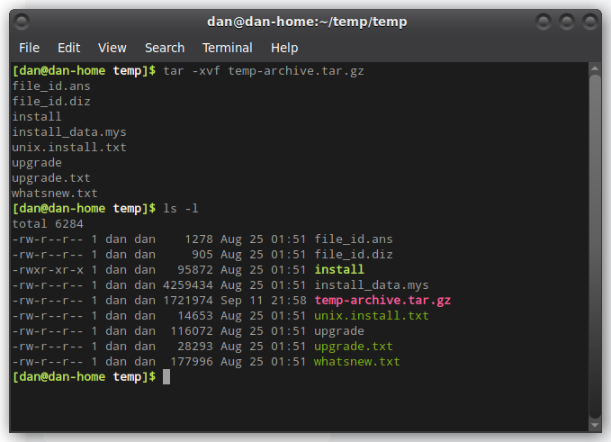
Again, similar command line to extract the archive as it was to compress it.

Uncompress a tar.bz2 Archive File

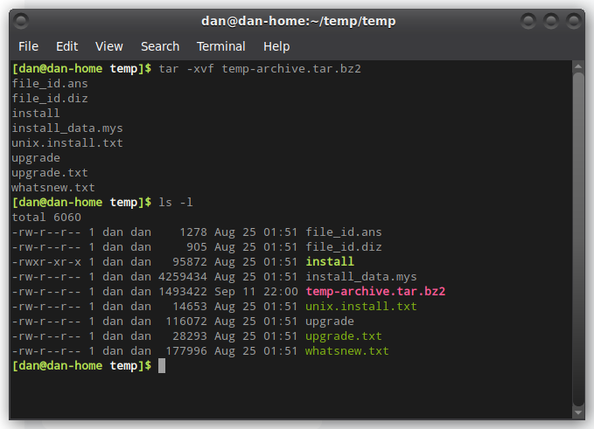
That is just the basic usage of the ‘tar’ command. There are many other things you can do with this command, but as I said, I could write an entire article on this topic.

whatis

This is a handy command to know, when someone tells you to run a command in the terminal, but you aren’t sure what the command does. Well, in each ‘man’ file, there is a 1 line synopsis of what the command does. The ‘whatis’ will pull that information and display it on the screen for you.

Let’s say someone tells you to run the ‘ls’ command, but you want to know what it is first. Just type in ‘whatis ls’.

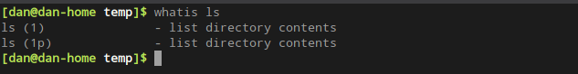
whoami

We’ve all had one of those nights where we don’t really remember who we are, right? Well this command might help you a little. :) When you type in this command in the Linux terminal, you will get your user name on the system. This really comes in handy if you are changing users for whatever reason, and can’t remember which one you are logged in as at the moment.

Never-mind the fact that I have my user name in my terminal prompt… :)

